Batch: B1 Roll No.: 1711072

Experiment / assignment / tutorial No. 1

Grade: AA / AB / BB / BC / CC / CD /DD

Signature of the Staff In-charge with date

TITLE: Study of PCI and SCSI.

AIM: To Study and learn PCI and SCSI
______________________________________________________________________
Expected OUTCOME of Experiment:

CO 1- Describe and define the structure of a computer with buses structure.
_____________________________________________________________________
Books/ Journals/ Websites referred:

- https://www.techopedia.com/definition/8815/peripheral-component-interconnect-bus-pci-bus
- https://www.techopedia.com/definition/331/small-computer-system-interface-scsi
- https://users.cs.jmu.edu/abzugcx/Public/Student-Produced-Term-Projects/Computer-Organization-2004-SPRING/PCI%20Bus-by-Lauren-Greenfield-Matt-Pozun-Lindsay-Stenger-Olivia-Ting-2004-Spring.ppt
- W. Stallings William “Computer Organization and Architecture: Designing for Performance”, Pearson Prentice Hall Publication, 7thEdition. C.
Pre Lab/ Prior Concepts:
Microcomputer buses which communicate with a peripheral devices or a memory location through communication lines called buses.
The major parts of microcomputers are central processing unit (CPU), memory, and input and output unit. To connect these parts together through three sets of parallel lines, called buses. These three buses are Address bus, data bus, and Control bus.

Address Bus:
The address bus consists of 16, 20, 24, or more parallel signal lines, through which the CPU sends out the address of the memory location. This memory location is used for to written to or read from. The number of memory location is depends on 2 to the power N address lines. Example, a CPU with 16 address lines can address 216 or 65,536 memory locations. When the CPU reads data from or writes data to a port. The port address is also sent out on the address bus. This is unidirectional. This means that the CPU can send data to a memory location or I/O ports.
Data Bus:
The data bus consists of 8, 16, 32 or more parallel signal lines. The data bus lines are bidirectional. This means that the CPU can read data from memory or from a I/O port as well as send data to a memory location or to a I/O port. In a system, many output devices are connected to the data bus, but only one device at a time will be enabled to the output.
Control Bus:
The control bus consists of 4-10 parallel signal lines. The CPU sends out signals on the control bus to enable the outputs of addressed memory devices or port devices. Typically control bus signals are memory read, memory write, I/O read and I/O write. To read a data from a memory location, the CPU sends out the address of the desired data on the address bus and then sends out a memory read signal on the control bus. The memory read signal enables the addressed memory device to output the data onto the data bus where it is read by the CPU.

PCI Bus
- The acronym PCI stands for Peripheral Component Interconnect, which aptly describes what it does. PCI was designed to satisfy the requirement for a standard interface for connecting peripherals to a PC, capable of sustaining the high data transfer rates needed by modern graphics controllers, storage media, network interface cards and other devices. PCI bus is based on ISA (Industry Standard Architecture) Bus and VL (VESA Local) Bus.
- Introduced by Intel in 1992.
- Revised twice into version 2.1 which is the 64-bit standard that it is today.
- Great feature of PCI Bus was that it was invented as an industry standard.
- PCI provides direct access to system memory for the devices that are connected to the bus which is then connected through a bridge that connects to the front side bus.
- This configuration allowed for higher performance without slowing down the processor.
- The PCI Bus was originally 33 MHz and then changed to 66 MHz.
- It has a current transfer speed of 1GB/s.
- PCI Bus became big with the release of Windows 95 with “Plug and Play” technology; as Plug and Play utilizes PCI bus concept.
- Three features make PSI one of the fastest I/O bus used today:
  - Burst Mode: allows multiple sets of data to be sent (Kozierok, 2001a)
  - Full Bus Mastering: the ability of devices on the PCI bus to perform transfers directly (Kozierok, 2001c)
  - High Bandwidth Options: allows for increased speed of the PCI (Kozierok, 2001a).
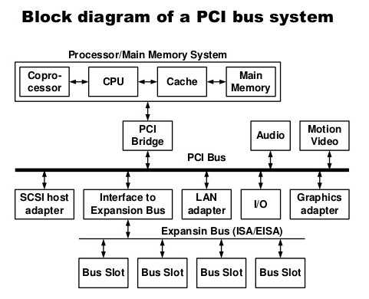
We can understand working of PCI through Plug and Play (PnP) as it utilizes the same concept.
- Once a new device has been inserted into a PCI slot on the motherboard.
- Operating System Basic Input/ Output System (BIOS) initiates “Plug and Play” (PnP) BIOS.
- PnP BIOS scans the PCI bus for any new hardware connected to the bus. If new hardware is found, it will ask for identification.
- The device will respond with its identification and send its device ID to the BIOS through the bus.
- PnP checks the Extended System Configuration Data (ESCD) to make sure the configuration data already exists for the card. (If the card is new, then there will be no data for it.)
- PnP will assign an Interrupt Request Line, Direct Memory Access, memory address and Input/ Output settings to the card, then stores the information in the ESCD.
- When the Windows software loads, it will check the PCI bus and the ESCD to see if there is new hardware. Windows will alert the user that new hardware has been found if there is new hardware installed and will also identify the hardware.
- Windows will determine the device and attempt to install its driver. The operating system may ask the user to insert a disk containing the driver or direct it to where the driver is located. In the event that Windows is unable to determine what the device is, it will provide a dialog window so the user can identify the hardware and load its driver.

Another example to understand how PCI works: Sound Card.
- The sound card will convert the analog signal to a digital signal.
- The digital audio data carried across the PCI bus to the bus controller, which determines which device on the PCI device has the priority to send data to the central processing unit (CPU) and whether the data will go directly to the CPU or to the system memory.
- If the sound card is in recording mode, the bus controller will assign a high priority to the data coming from the sound card. It will send the sound cards data over the bus bridge to the system bus.
- The system bus will save the data in system memory. When the recording is complete, then it will be up to the user to save the data from the sound card on either the hard drive, or will remain in memory for additional processing.
Other types of PCI:
- Original PCI
- PCI 2.3
- PCI-X
  - PCI-X 2.0 (second revision)
- PCI Express
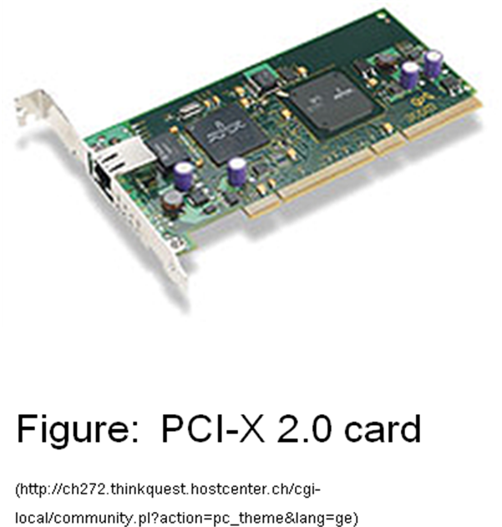

SCSI bus:
SCSI stands for Small Computer System Interface. It is pronounced as "Scuzzy" and is one of the most commonly used interface for disk drives that was first completed in 1982 by American National Standards Institute (ANSI). Unlike competing standards, SCSI is capable of supporting eight devices, or sixteen devices with Wide SCSI. However, with the SCSI host adapter located on ID number 07 and boots from the ID 00. This leaves the availability of six device connections. In the picture below, is an example of a SCSI adapter expansion card with an internal and external connection. Once installed in the computer this adapter would allow multiple SCSI devices to be installed in the computer. More advanced motherboard may also have available SCSI connections on the motherboard. The types of SCSI include:
- SCSI-1 is the original SCSI standard developed back in 1986 as ANSI X3.131-1986. SCSI-1 is capable of transferring up to eight bits a second.
- SCSI-2 was approved in 1990, added new features such as Fast and Wide SCSI, and support for additional devices.
- SCSI-3 was approved in 1996 as ANSI X3.270-1996.
SCSI is a standard for parallel interfaces that transfers information at a rate of eight bits per second and faster, which is faster than the average parallel interface. SCSI-2 and above supports up to seven peripheral devices, such as a hard drive, CD-ROM, and scanner, that can attach to a single SCSI port on a system's bus. SCSI ports were designed for Apple Macintosh and Unix computers, but also can be used with PCs. Although SCSI has been popular in the past, today many users are switching over to SATA drives.
SCSI is used to increase performance, deliver faster data transfer transmission and provide larger expansion for devices such as CD-ROM drives, scanners, DVD drives and CD writers. SCSI is also frequently used with RAID, servers, high-performance PCs and storage area networks SCSI has a controller in charge of transferring data between the devices and the SCSI bus. It is either embedded on the motherboard or a host adapter is inserted into an expansion slot on the motherboard. The controller also contains SCSI basic input/output system, which is a small chip providing the required software to access and control devices. Each device on a parallel SCSI bus must be assigned a number between 0 and 7 on a narrow bus or 0 and 15 on a wider bus. This number is called an SCSI ID. Newer serial SCSI IDs such as serial attached SCSI (SAS) use an automatic process assigning a 7-bit number with the use of serial storage architecture initiators.
On an SCSI bus, each possible pair of devices can communicate. Whether their function allows this is another matter, but the standard does not restrict it.

The main phases involved in the operation of the SCSI bus are:
- Arbitration
- Selection
- Information Transfer
- Reselection

Arbitration:

The bus is free when the BSY signal is in the inactive (high voltage) state. Any controller can request the use of the bus while it is in this state. Since two or more controllers may generate such a request at the same time, an arbitration scheme must be implemented. A controller requests the bus by asserting the -BSY signal and by asserting its associated data line to identify itself. Each controller in the bus is assigned a fixed priority, with controller 7 having highest priority. When -BSY becomes active, all controllers that are requesting the bus examine the data lines and determine whether a higher priority device is requesting the bus at the same time. The controller using the highest numbered line realizes that it has won the arbitration.

Selection:

Having won arbitration, controller 6 continues to assert -BSY and -DB6 (its address). It indicates that it wishes to select controller 5 by asserting the -SEL and then the -DB5 line. The selected target controller responds by asserting -BSY. This informs the initiator that the connection it is requesting has been established, so that it may remove the address information from data lines. The selection process is now complete, and the target controller is asserting -BSY.

Information Transfer:

The information transferred between two controllers may consist of commands from the initiator to the target, status responses from the target to the initiator, or data being transferred to or from the I/O device. Handshake signaling is used to control information transfers. The target asserts -I/O during an input operation (target to initiator) and it asserts -C/D to indicate that information is a command or status response. At the end of the transfer, the target controller releases -BSY signal, thus freeing the bus for use by other devices.

Reselection:

When a logical connection is suspended and the target is ready to restore it, the target must first gain control of the bus. It starts an arbitration cycle, and after winning arbitration, it selects the initiator. The initiator is now asserting -BSY. The initiator waits for short period after being selected to make sure that target has asserted -BSY, and then releases the -BSY line. The connection between the two controllers has now been reestablished, with the target in control of the bus as required for data transfer to proceed.

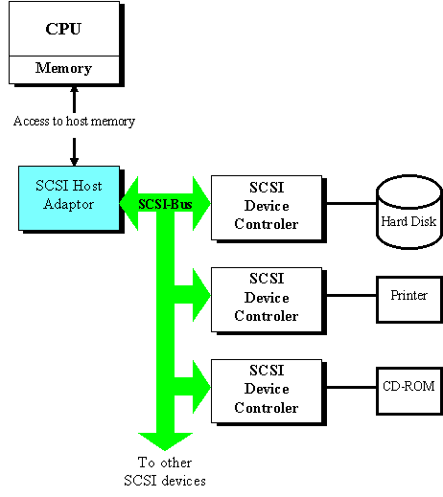
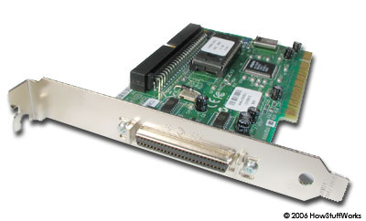

Conclusion: The aim of the experiment has been achieved.

Post Lab Descriptive Questions (Add questions from examination point view)

Q1. Differentiate between PCI and SCSI Bus.

Q2. List the application of PCI and SCSI Bus.

A2. Applications of PCI bus:
- Used in sound cards.
- Plug and play feature utilizes the concept of PCI.
- Useful in high quality live streaming and image/video processing.

Applications of SCSI bus:
- SCSI is used to connect peripherals to a computer.
- Used for connecting hard disks, tape devices, CD-ROMs, scanners, printers and many other devices to PC.
- SCSI is mostly used in server nowadays and in computers which require a very good performance.

Date: 18/07/2018 Signature of faculty in-charge

Batch: Roll No.:

Experiment / assignment / tutorial No._______

Grade: AA / AB / BB / BC / CC / CD /DD

Signature of the Staff In-charge with date

TITLE: To study and implement Booth’s Multiplication Algorithm.

AIM: Booth’s Algorithm for Multiplication
______________________________________________________________________
Expected OUTCOME of Experiment:

CO 2-Detail working of the arithmetic logic unit and its sub modules
_____________________________________________________________________
Books/ Journals/ Websites referred:

- Carl Hamacher, Zvonko Vranesic and Safwat Zaky, “Computer Organization”, Fifth Edition, TataMcGraw-Hill.
- William Stallings, “Computer Organization and Architecture: Designing for Performance”, Eighth Edition, Pearson.
3. Dr. M. Usha, T. S. Srikanth, “Computer System Architecture and Organization”, First Edition, Wiley-India.
_____________________________________________________________________
Pre Lab/ Prior Concepts:

It is a powerful algorithm for signed number multiplication which generates a 2n bit product and treats both positive and negative numbers uniformly. Also the efficiency of the algorithm is good due to the fact that, block of 1’s and 0’s are skipped over and subtraction/addition is only done if pair contains 10 or 01

Flowchart:

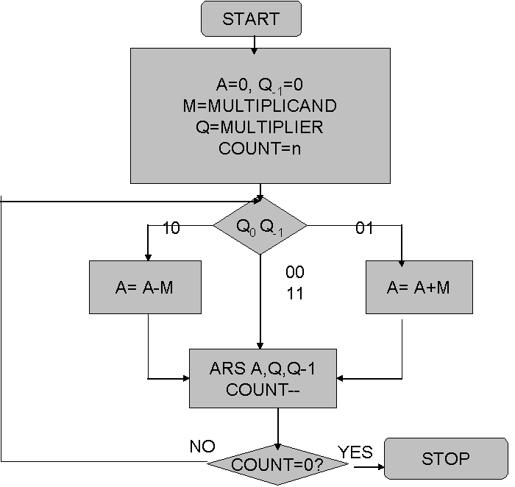

Design Steps:
- Start
- Get the multiplicand (M) and Multiplier (Q) from the user
- Initialize A= Q₋₁ =0
- Convert M and Q into binary
- Compare Q₀ and Q₋₁ and perform the respective operation.
Q₀ Q₋₁ | Operation
00/11 | Arithmetic right shift
01 | A+M and Arithmetic right shift
10 | A-M and Arithmetic right shift

6. Repeat steps 5 till all bits are compared
7. Convert the result to decimal form and display
8. End

Example:

Conclusion:
Date: _____________ Signature of faculty in-charge

Post Lab Descriptive Questions (Add questions from examination point view)

1. Draw the Circuit diagram for booths algorithm.
2. Explain advantages and disadvantages of booth algorithm

Batch: Roll No.:

Experiment / assignment / tutorial No._______

Grade: AA / AB / BB / BC / CC / CD /DD

Signature of the Staff In-charge with date

TITLE : To study and implement Restoring method of division

AIM : The basis of algorithm is based on paper and pencil approach and the operation involve repetitive shifting with addition and subtraction. So the main aim is to depict the usual process in the form of an algorithm.
______________________________________________________________________
Expected OUTCOME of Experiment:

CO 2-Detail working of the arithmetic logic unit and its sub modules
CO 3-Understand the Central processing unit with addressing modes and working of control unit
_____________________________________________________________________
Books/ Journals/ Websites referred:

- Carl Hamacher, Zvonko Vranesic and Safwat Zaky, “Computer Organization”, Fifth Edition, TataMcGraw-Hill.
- William Stallings, “Computer Organization and Architecture: Designing for Performance”, Eighth Edition, Pearson.
3. Dr. M. Usha, T. S. Srikanth, “Computer System Architecture and Organization”, First Edition, Wiley-India.
_____________________________________________________________________
Pre Lab/ Prior Concepts:
The Restoring algorithm works with any combination of positive and negative numbers.

Flowchart for Restoring of Division:
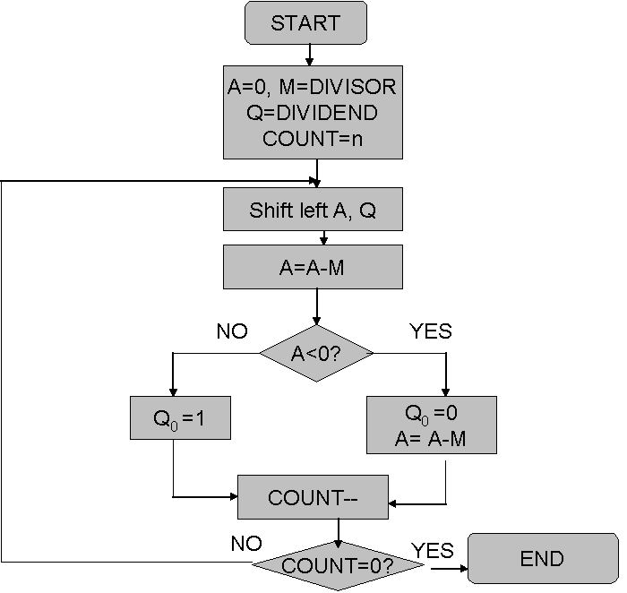

Design Steps:
- 1Start
- 2Initialize A=0, M=Divisor, Q=Dividend and count=n (no of bits)
- Left shift A, Q
- If MSB of A and M are same
- Then A=A-M
- Else A=A+M
- If MSB of previous A and present A are same
- Q₀=0 & store present A
- Else Q₀=0 & restore previous A
- Decrement count.
- If count=0 go to 11
- Else go to 3
- STOP

Example:

Conclusion

Post Lab Descriptive Questions (Add questions from examination point view)

- What are the advantages of non restoring division over restoring division?

2. Simulate non restoring division algorithm for unsigned numbers A=1101 and B=0101

Date: _____________ Signature of faculty in-charge

Batch: Roll No.:

Experiment / assignment / tutorial No._______

Grade: AA / AB / BB / BC / CC / CD /DD

Signature of the Staff In-charge with date

TITLE : To study and implement Non Restoring method of division

AIM : The basis of algorithm is based on paper and pencil approach and the operation involve repetitive shifting with addition and subtraction. So the main aim is to depict the usual process in the form of an algorithm.
______________________________________________________________________
Expected OUTCOME of Experiment:

CO 2-Detail working of the arithmetic logic unit and its sub modules
CO 3-Understand the Central processing unit with addressing modes and working of control unit
_____________________________________________________________________
Books/ Journals/ Websites referred:

- Carl Hamacher, Zvonko Vranesic and Safwat Zaky, “Computer Organization”, Fifth Edition, TataMcGraw-Hill.
- William Stallings, “Computer Organization and Architecture: Designing for Performance”, Eighth Edition, Pearson.
3. Dr. M. Usha, T. S. Srikanth, “Computer System Architecture and Organization”, First Edition, Wiley-India.
_____________________________________________________________________
Pre Lab/ Prior Concepts:
The Non Restoring algorithm works with any combination of positive and negative numbers.

Flowchart for Non Restoring of Division:

Example:

Conclusion

Post Lab Descriptive Questions (Add questions from examination point view)

- What are the advantages of non restoring division over restoring division?

2. Simulate non restoring division algorithm for unsigned numbers A=1101 and B=0101

Batch: Roll No.:

Experiment / assignment / tutorial No._______

Grade: AA / AB / BB / BC / CC / CD /DD

Signature of the Staff In-charge with date

TITLE: Implementation of IEEE-754 floating point representation

AIM: To demonstrate the single and double precision formats to represent floating point numbers.
______________________________________________________________________
Expected OUTCOME of Experiment:

CO 2-Detail working of the arithmetic logic unit and its sub modules
___________________________________________________________________
Books/ Journals/ Websites referred:
- Carl Hamacher, Zvonko Vranesic and Safwat Zaky, “Computer Organization”, Fifth Edition, TataMcGraw-Hill.
- William Stallings, “Computer Organization and Architecture: Designing for Performance”, Eighth Edition, Pearson.
_____________________________________________________________________
Pre Lab/ Prior Concepts:
The IEEE Standard for Floating-Point Arithmetic (IEEE 754) is a technical standard for floating-point computation established in 1985 by the Institute of Electrical and Electronics Engineers (IEEE). The standard addressed many problems found in the diverse floating point implementations that made them difficult to use reliably and portably. Many hardware floating point units now use the IEEE 754 standard.
The standard defines:
- arithmetic formats: sets of binary and decimal floating-point data, which consist of finite numbers (including signed zeros and subnormal numbers), infinities, and special "not a number" values (NaNs)
- interchange formats: encodings (bit strings) that may be used to exchange floating-point data in an efficient and compact form
- rounding rules: properties to be satisfied when rounding numbers during arithmetic and conversions
- operations: arithmetic and other operations (such as trigonometric functions) on arithmetic formats
- exception handling: indications of exceptional conditions (such as division by zero, overflow, etc

Example (Single Precision- 32 bit representation )

Example (Double Precision- 64 bit representation )

Post Lab Descriptive Questions (Add questions from examination point view)
- Give the importance of IEEE-754 representation for floating point numbers?

Conclusion

Date: _____________ Signature of faculty in-charge

Batch: Roll No.:

Experiment / assignment / tutorial No._______

Grade: AA / AB / BB / BC / CC / CD /DD

Signature of the Staff In-charge with date

TITLE: Implementation of LRU Page Replacement Algorithm.

AIM: The LRU algorithm replaces the least recently used that is the last accessed memory block from user.
______________________________________________________________________
Expected OUTCOME of Experiment:

CO 4-Learn and evaluate memory organization and cache structure
___________________________________________________________________
Books/ Journals/ Websites referred:
- Carl Hamacher, Zvonko Vranesic and Safwat Zaky, “Computer Organization”, Fifth Edition, TataMcGraw-Hill.
- William Stallings, “Computer Organization and Architecture: Designing for Performance”, Eighth Edition, Pearson.
_____________________________________________________________________
Pre Lab/ Prior Concepts:

It follows a simple logic, while replacing it will replace that page which has least recently used out of all.
a) A hit is said to be occurred when a memory location requested is already in the cache.
b) When cache is not full, the number of blocks is added.
c) When cache is full, the block is replaced which is recently used
Algorithm:

- Start
- Get input as memory block to be added to cache
- Consider an element of the array
- If cache is not full, add element to the cache array
- If cache is full, check if element is already present
- If it is hit is incremented
- If not, element is added to cache removing least recently used element
- Repeat step 3 to 7 for remaining elements
- Display the cache at very instance of step 8
- Print hit ratio
- End

Example:

Post Lab Descriptive Questions (Add questions from examination point view)

1. Define hit rate and miss ratio?

2. What is the need for virtual memory?

Conclusion

Date: _____________ Signature of faculty in-charge

Batch: Roll No.:

Experiment / assignment / tutorial No._______

Grade: AA / AB / BB / BC / CC / CD /DD

Signature of the Staff In-charge with date

TITLE :Implementation of FIFO Page Replacement Algorithm

AIM: The FIFO algorithm uses the principle that the block in the set which has been in for the longest time will be replaced
______________________________________________________________________
Expected OUTCOME of Experiment:
CO 4-Learn and evaluate memory organization and cache structure
_____________________________________________________________________
Books/ Journals/ Websites referred:
- Carl Hamacher, Zvonko Vranesic and Safwat Zaky, “Computer Organization”, Fifth Edition, TataMcGraw-Hill.
- William Stallings, “Computer Organization and Architecture: Designing for Performance”, Eighth Edition, Pearson.
3. Dr. M. Usha, T. S. Srikanth, “Computer System Architecture and Organization”, First Edition, Wiley-India.
---------------------------------------------------------------------------------------------------------
Pre Lab/ Prior Concepts:

T he FIFO algorithm uses the principle that the block in the set which has been in the block for the longest time is replaced. FIFO is easily implemented as a round robin or criteria buffer technique. The data structure used for implementation is a queue. Assume that the number of cache pages is three. Let the request to this cache is shown alongside.

Algorithm:

1. A hit is said to be occurred when a memory location requested is already in the cache.
2. When cache is not full, the number of blocks is added.
3. When cache is full, the block is replaced which was added first

Design Steps:

- Start
- Get input as memory block to be added to cache
- Consider an element of the array
- If cache is not full, add element to the cache array
- If cache is full, check if element is already present
- If it is hit is incremented
- If not, element is added to cache removing first element (which is in first).
- Repeat step 3 to 7 for remaining elements
- Display the cache at very instance of step 8
- Print hit ratio
- End.

Example:

Post Lab Descriptive Questions (Add questions from examination point view)

1. What is meant by memory interleaving?
2. Explain Paging Concept?

Conclusion

Date: _____________ Signature of faculty in-charge

Batch: Roll No.:

Experiment / assignment / tutorial No._______

Grade: AA / AB / BB / BC / CC / CD /DD

Signature of the Staff In-charge with date

TITLE : Implementation of Cache Mapping Techniques.

AIM: To study and implement concept of various mapping techniques designed for cache memory.
______________________________________________________________________
Expected OUTCOME of Experiment:
CO 4-Learn and evaluate memory organization and cache structure
_____________________________________________________________________
Books/ Journals/ Websites referred:

- Carl Hamacher, Zvonko Vranesic and Safwat Zaky, “Computer Organization”, Fifth Edition, TataMcGraw-Hill.
- Dr. M. Usha, T. S. Srikanth, “Computer System Architecture and Organization”, First Edition, Wiley-India.
___________________________________________________________
Pre Lab/ Prior Concepts:

Cache memory: The cache is a smaller, faster memory which stores copies of the data from the most frequently used main memory locations. As long as most memory accesses are cached memory locations, the average latency of memory accesses will be closer to the cache latency than to the latency of main memory.
2. Hit Ratio: You want to increase as much as possible the likelihood of the cache containing the memory addresses that the processor wants.
Hit Ratio= No. of hits/ (No. of hits + No. of misses)
There are only fewer cache lines than the main memory blocks, an algorithm is needed for mapping main memory blocks into cache lines. Further a means is needed for determining which main memory block currently occupies in a cache line. The choice of cache function dictates how the cache is organized. Three techniques can be used.
- Direct mapping.
- Associative mapping.
- Set Associative mapping.
Direct Mapped Cache: The direct mapped cache is the simplest form of cache and the easiest to check for a hit. Since there is only one possible place that any memory location can be cached, there is nothing to search; the line either contains the memory information we are looking for, or it doesn't.
Unfortunately, the direct mapped cache also has the worst performance, because again there is only one place that any address can be stored. Let's look again at our 512 KB level 2 cache and 64 MB of system memory. As you recall this cache has 16,384 lines (assuming 32-byte cache lines) and so each one is shared by 4,096 memory addresses. In the absolute worst case, imagine that the processor needs 2 different addresses (call them X and Y) that both map to the same cache line, in alternating sequence (X, Y, X, Y). This could happen in a small loop if you were unlucky. The processor will load X from memory and store it in cache. Then it will look in the cache for Y, but Y uses the same cache line as X, so it won't be there. So Y is loaded from memory, and stored in the cache for future use. But then the processor requests X, and looks in the cache only to find Y. This conflict repeats over and over. The net result is that the hit ratio here is 0%. This is a worst case scenario, but in general the performance is worst for this type of mapping.

Fully Associative Cache: The fully associative cache has the best hit ratio because any line in the cache can hold any address that needs to be cached. This means the problem seen in the direct mapped cache disappears, because there is no dedicated single line that an address must use.However (you knew it was coming), this cache suffers from problems involving searching the cache. If a given address can be stored in any of 16,384 lines, how do you know where it is? Even with specialized hardware to do the searching, a performance penalty is incurred. And this penalty occurs for all accesses to memory, whether a cache hit occurs or not, because it is part of searching the cache to determine a hit. In addition, more logic must be added to determine which of the various lines to use when a new entry must be added (usually some form of a "least recently used" algorithm is employed to decide which cache line to use next). All this overhead adds cost, complexity and execution time.
Set Associative Cache:

Direct Mapping Implementation:
The mapping is expressed as
i=j modulo m
i=cache line number
j= main memory block number
m= number of lines in the cache
- Address length = (s+w) bits
- Number of addressable units = 2^{s+w} words or bytes
- Block size = line size = 2^{w} words or bytes
- Number of blocks in main memory = 2^{s+w} / 2^{w} = 2^{s}
- Number of lines in cache = m = 2^{r}
- Size of tag = (s-r) tags

Associative Mapping Implementation:

Set Associative Mapping Implementation:

Post Lab Descriptive Questions (Add questions from examination point view)

1. For a direct mapped cache, a main memory is viewed as consisting of 3 fields. List and define 3 fields.

2. What is the general relationship among access time, memory cost, and capacity?

Conclusion

Date: _____________ Signature of faculty in-charge

Batch: Roll No.:

Experiment / assignment / tutorial No._______

Grade: AA / AB / BB / BC / CC / CD /DD

Signature of the Staff In-charge with date

TITLE: Implementation of RAID levels

AIM: Understanding RAID levels and their importance
_______________________________________________________________
Expected OUTCOME of Experiment:
CO 4-Learn and evaluate memory organization and cache structure
CO 5- Summarize Input output techniques and multiprocessor configurations
__________________________________________________________________
Books/ Journals/ Websites referred:

- Carl Hamacher, Zvonko Vranesic and Safwat Zaky, “Computer Organization”, Fifth Edition, TataMcGraw-Hill.
- William Stallings, “Computer Organization and Architecture: Designing for Performance”, Eighth Edition, Pearson.
3. Dr. M. Usha, T. S. Srikanth, “Computer System Architecture and Organization”, First Edition, Wiley-India.
_____________________________________________________________________

Pre Lab/ Prior Concepts: RAID: Short for Redundant Array of Independent (or Inexpensive) Disks, a category of disk drives that employ two or more drives in combination for fault tolerance and performance. RAID disk drives are used frequently on servers but aren't generally necessary for personal computers. RAID allows you to store the same data redundantly (in multiple paces) in a balanced ay to improve overall performance.
Disk Drives: A machine that reads data from and writes data onto a disk. A disk drive
rotates the disk very fast and has one or more heads that read and write data
Fault Tolerance: The ability of a system to respond gracefully to an unexpected hardware or software failure. There are many levels of fault tolerance, the lowest being the ability to continue operation in the event of a power failure. Many fault-tolerant computer systems mirror all operations -- that is, every operation is performed on two or more duplicate systems, so if one fails the other can take over
Resources required: c programming.

Methodology:
RAID 0
.
A RAID 0 (also known as a stripe set or striped volume) splits data evenly across two or more disks (striped) with no parity information for redundancy. It is important to note that RAID 0 was not one of the original RAID levels and provides no data redundancy. RAID 0
is normally used to increase performance, although it can also be used as a way to create a small number of large virtual disks out of a large number of small physical ones. A RAID 0 can be created with disks of differing sizes, but the storage space added to the array by each disk is limited to the size of the smallest disk. For example, if a 120 GB disk is striped together with a 100 GB disk, the size of the array will be 200 GB.

RAID 1
A RAID 1 creates an exact copy (or mirror) of a set of data on two or more disks. This is
useful when read performance or reliability are more important than data storage
capacity such an array can only be as big as the smallest member disk. A classic RAID 1 mirrored pair contains two disks (see diagram), which increases reliability geometrically each member contains a complete copy of the data, and can be addressed independently, ordinary wear-and-tear reliability is raised by the power of the number of self-contained copies.
.
RAID 2
A RAID 2 stripes data at the bit (rather than block) level, and uses a Hamming code for
error correction. The disks are synchronized by the controller to spin in perfect tandem.
Extremely high data transfer rates are possible. This is the only original level of RAID that is not currently used.
The use of the Hamming(7,4) code (four data bits plus three parity bits) also permits using 7 disks in RAID 2, with 4 being used for data storage and 3 being used for error
correction.RAID 2 is the only standard RAID level, other than some implementations of RAID 6,which can automatically recover accurate data from single-bit corruption in data. Other RAID levels can detect single-bit corruption in data, or can sometimes reconstruct missing data, but cannot reliably resolve contradictions between parity bits and data bits without human intervention.
(Multiple-bit corruption is possible though extremely rare. RAID 2 can detect but not repair double-bit corruption.)
At the present time, there are no commercial implementations of RAID 2

Design Steps:
Raid level 0

Raid level 1

Raid level 2

Post Lab Descriptive Questions (Add questions from examination point view)

1. What are the applications of RAID levels ? Which level is the most secure?

Conclusion

Date: _____________ Signature of faculty in-charge

